**IBM Nalaiya Thiran**

**IBM-Project-11124-1659267524**

**ASSIGNMENT - 1**

**Name: Sudharsanan M**

**Roll no:** 19BCS080

**Project: Corporate Employee Attrition Analytics**

**Exploring and visualizing the 50 start-ups dataset:**

1. **Profit by State:**

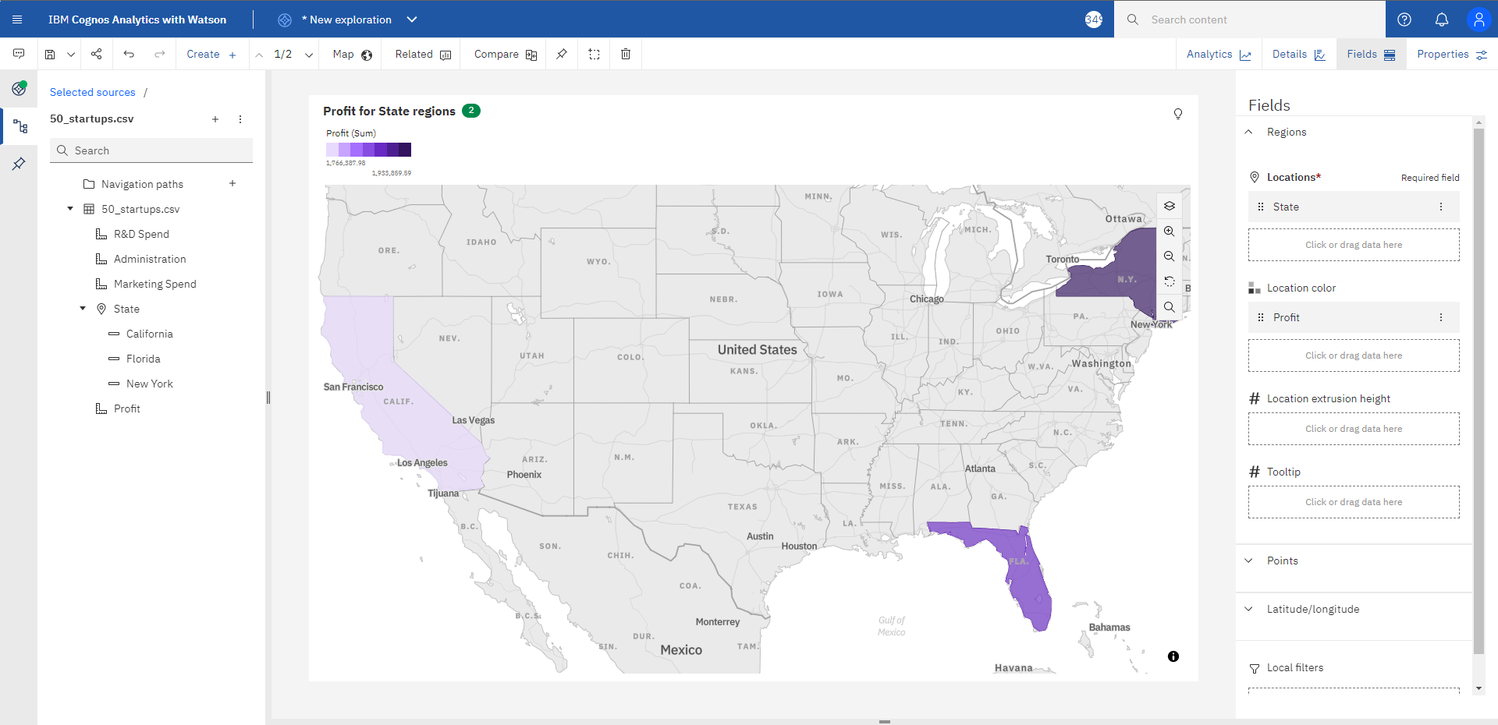

1. **All Spends by State:**

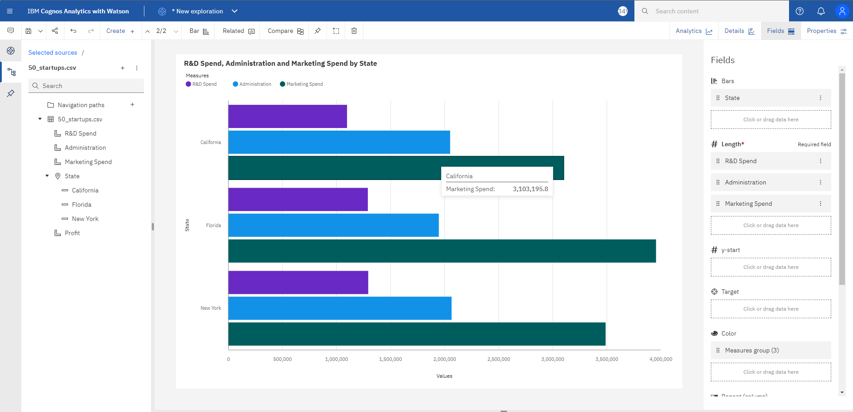

1. **Profit and R&D Spend, Administration and Marketing Spend by State:**

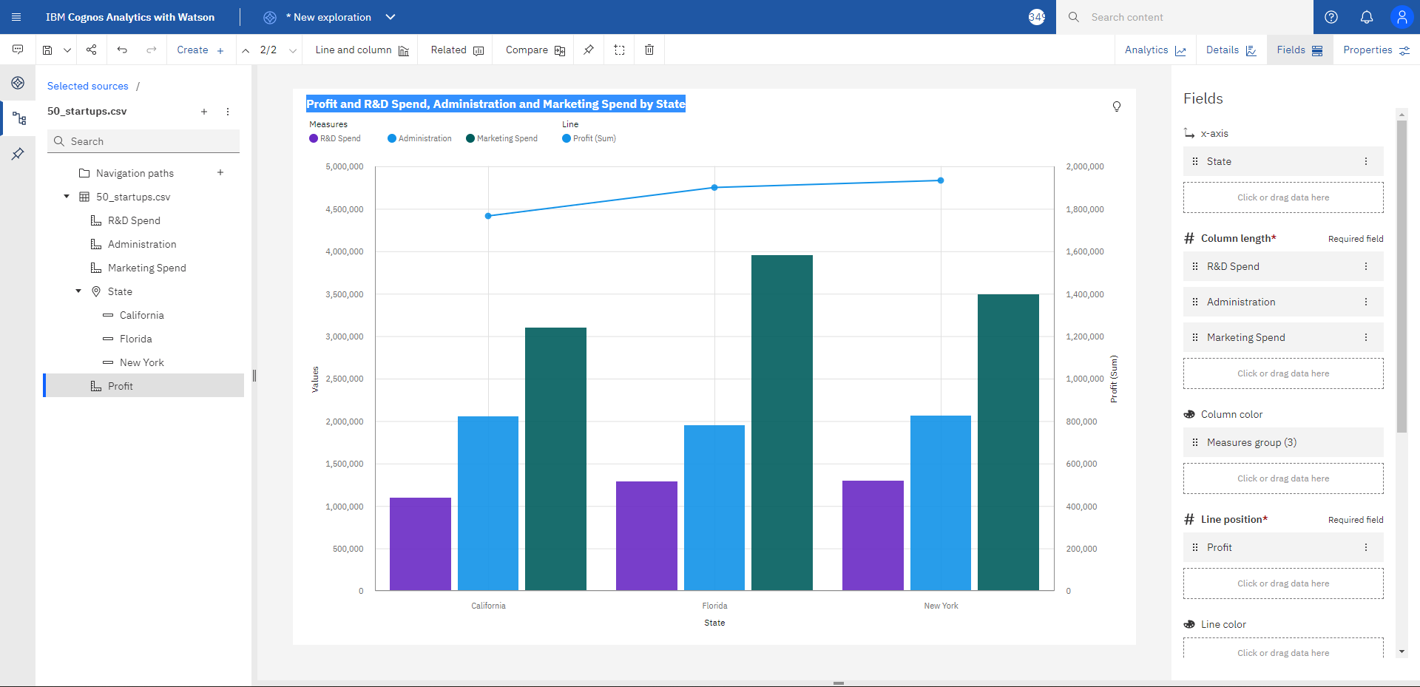

1. **Comparison on Marketing and R&D Spend by State:**

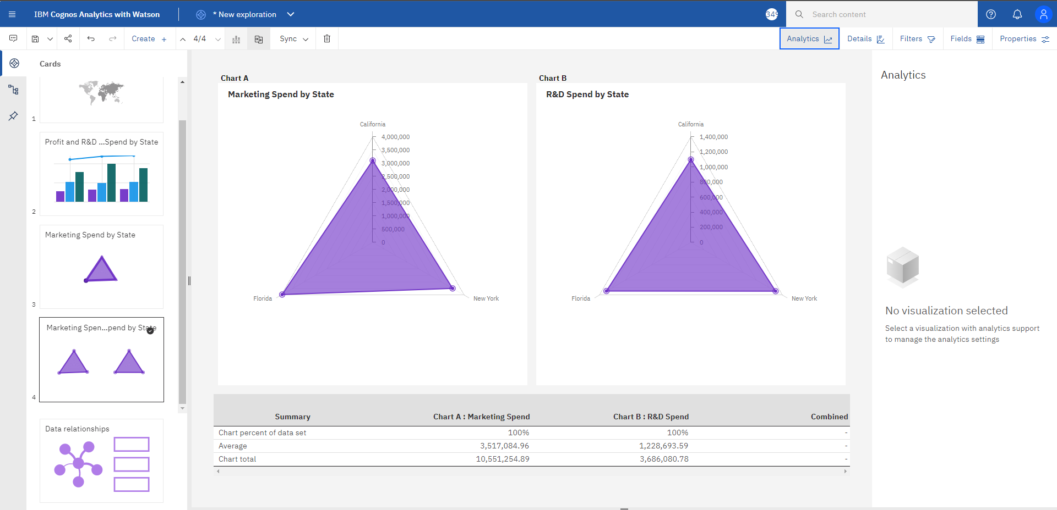

1. **Administration spend by State:**

